|  |
| --- |
| Activity 4.1: Installing Anaconda, Jupyter, and Atom |

**Table of contents**

Contents

Activity 4.1: Installing Anaconda, Jupyter, and Atom 1

Task 1: Installing Anaconda on Windows 1

Launching “Anaconda Navigator” 7

Adding Python to the environment variable 8

Task 2: Installing Anaconda on Linux 10

Simplest way to Launch Python Tools 13

Launch interactive Python shell: 13

Launch Spyder IDE: 14

Installing Atom Editor: 15

# Task 1: Installing Anaconda on Windows

Visit [www.anaconda.com/download/](http://www.anaconda.com/download/)

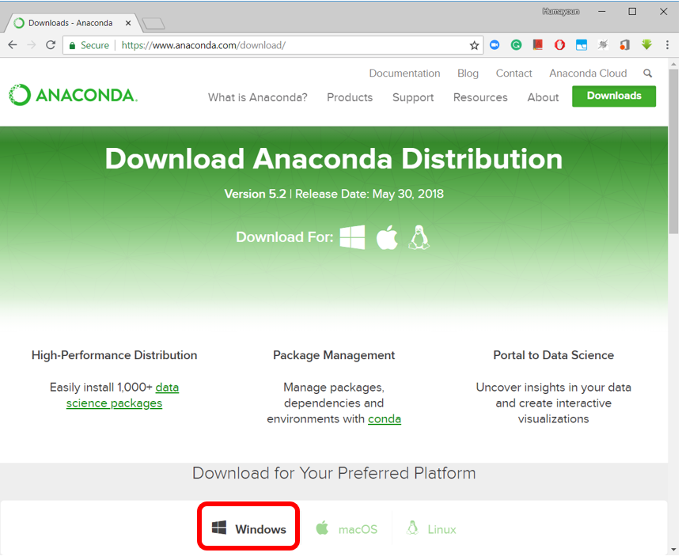

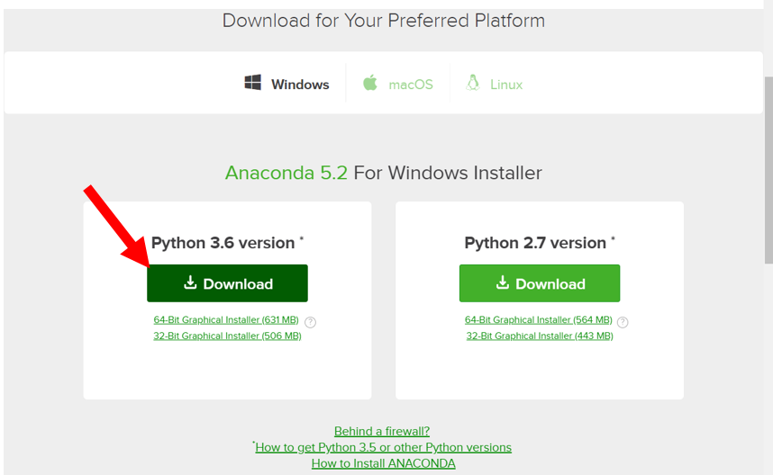

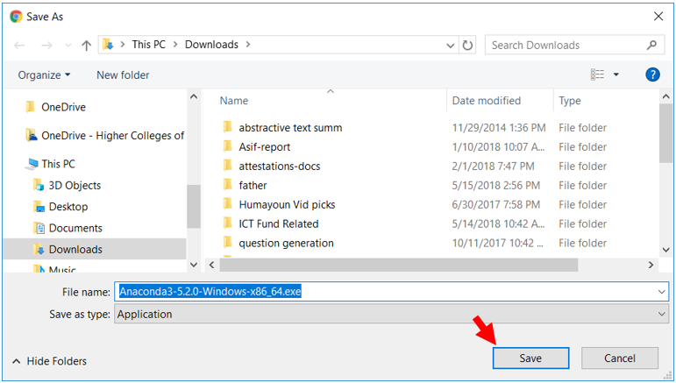

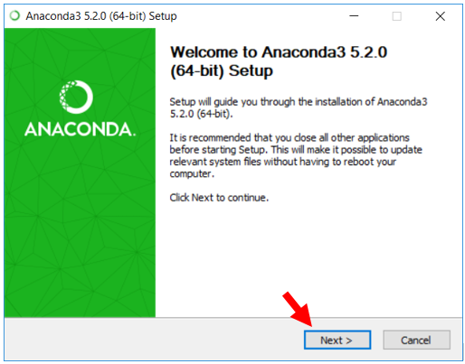

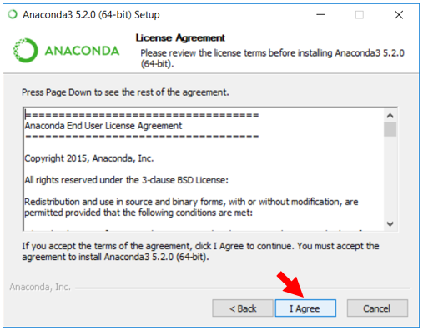

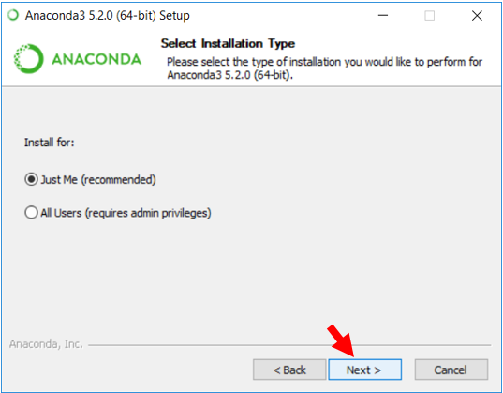

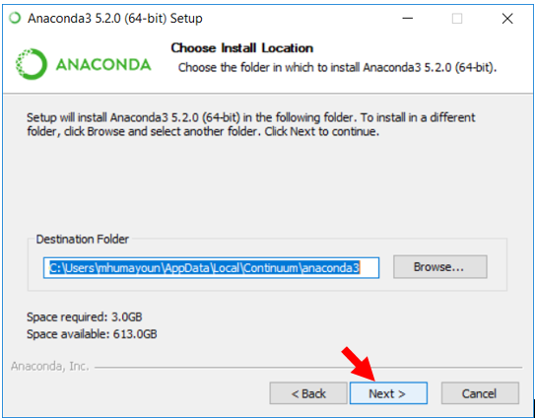

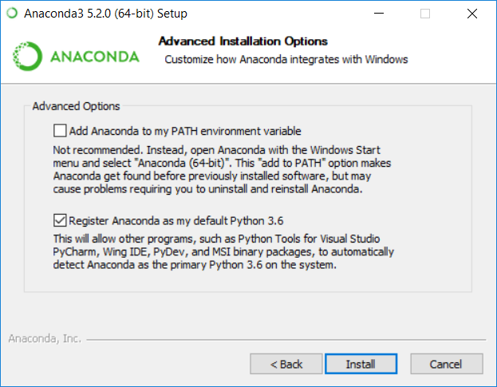

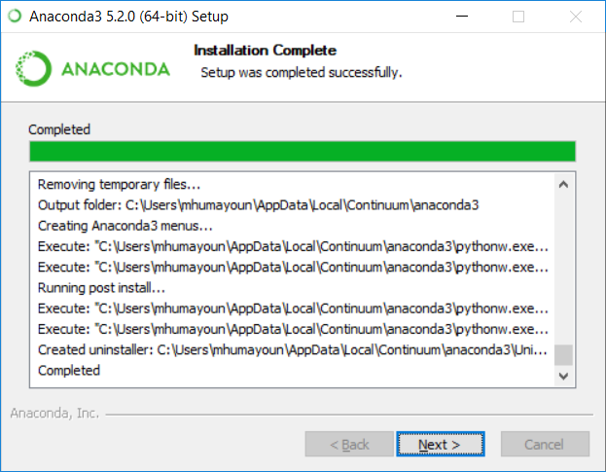

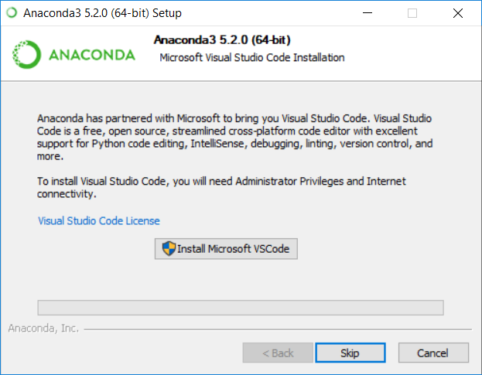

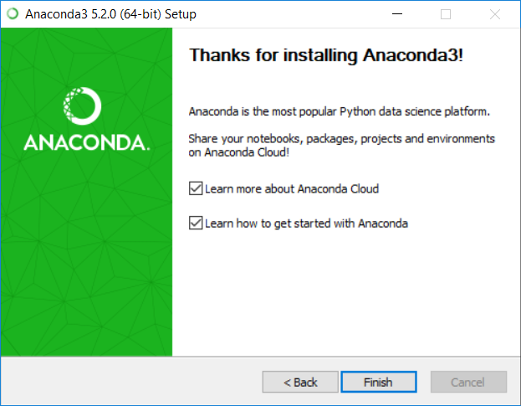

## Start Jupyter Notebook:

Click on start button and start typing “Jupyter”, you’ll see this:

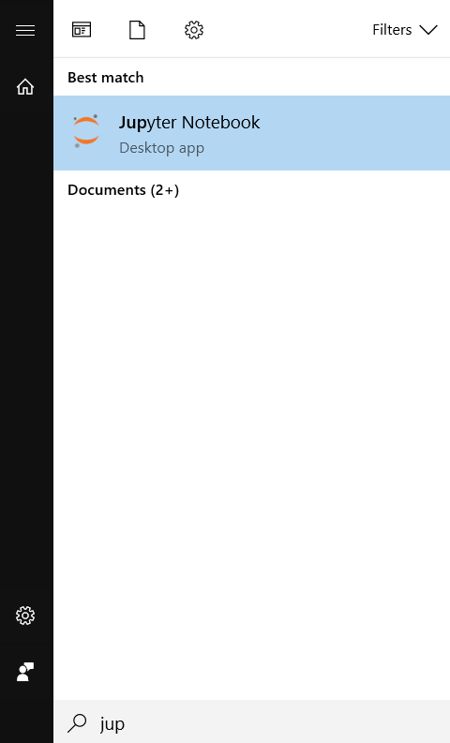

# Launching “Anaconda Navigator”

There are a number of additional tools and software that you can get from Anaconda Navigator.

Click on start button and start typing “anaconda”, you’ll see this:

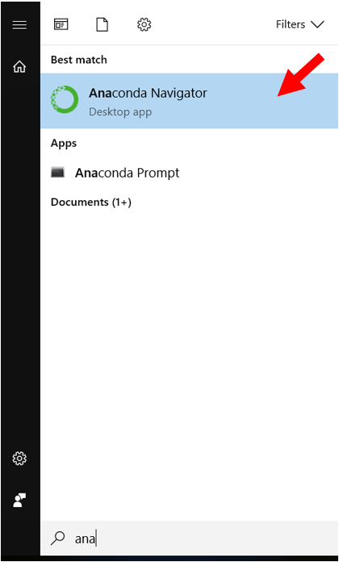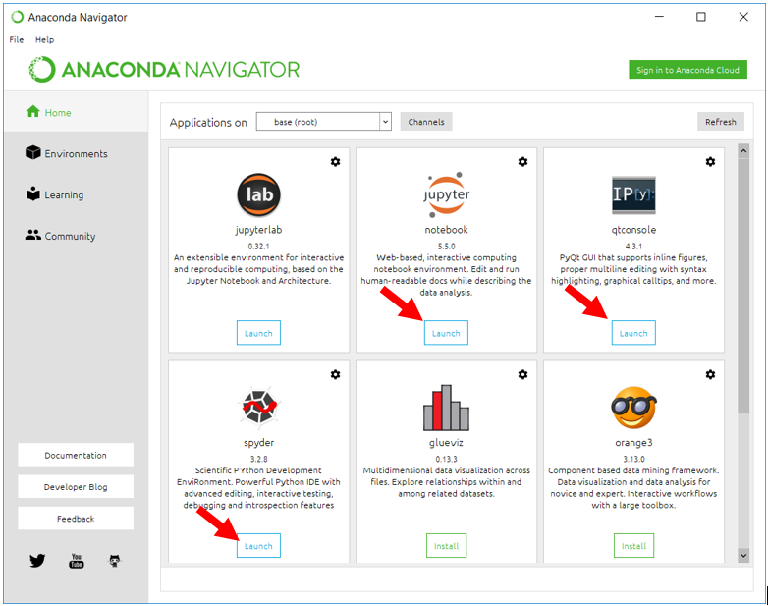Click on “launch” buttons to launch these applications.

# Task 2: Installing Anaconda on Linux

Source: <https://conda.io/docs/user-guide/getting-started.html>

Visit [www.anaconda.com/download/](http://www.anaconda.com/download/)

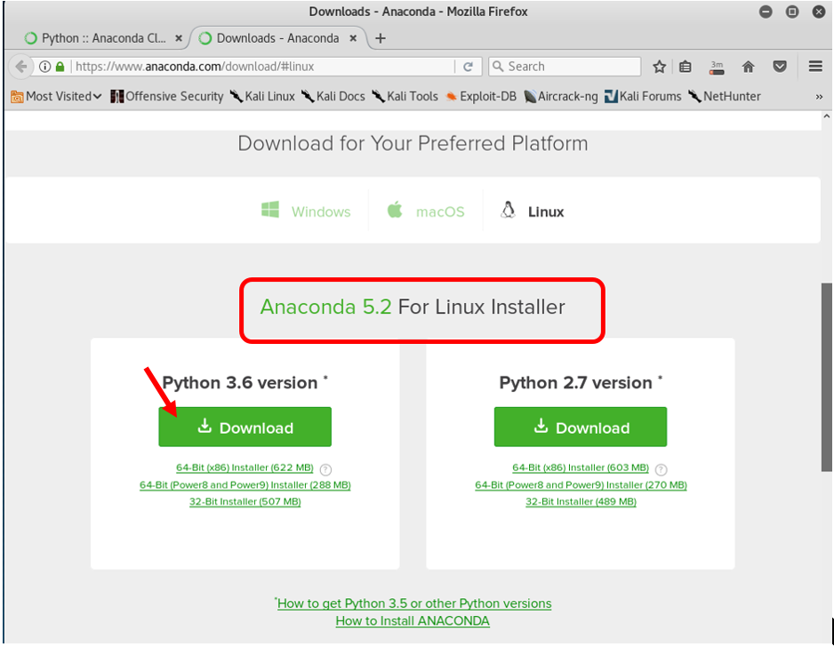

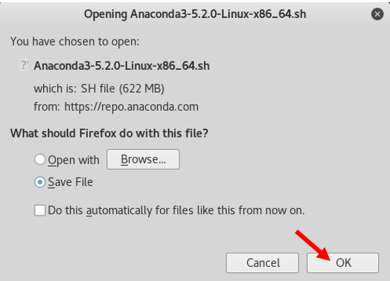

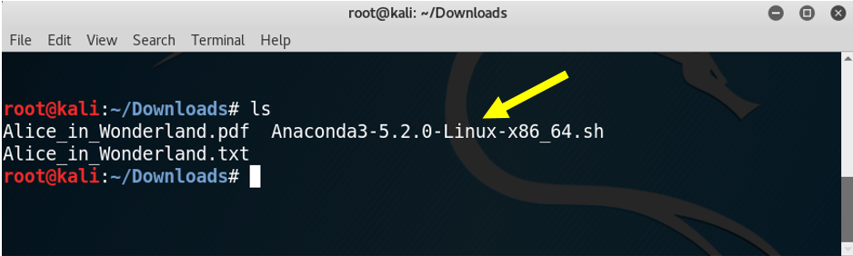

Make the script executable:

**root@kali:~/Downloads#** chmod +x Anaconda3-5.2.0-Linux-x86_64.sh

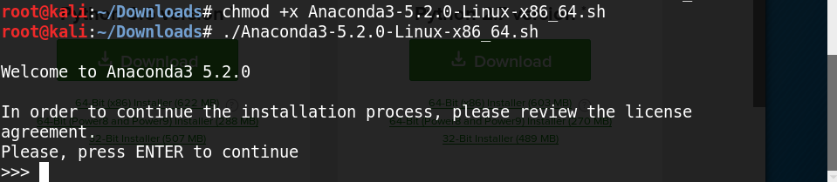

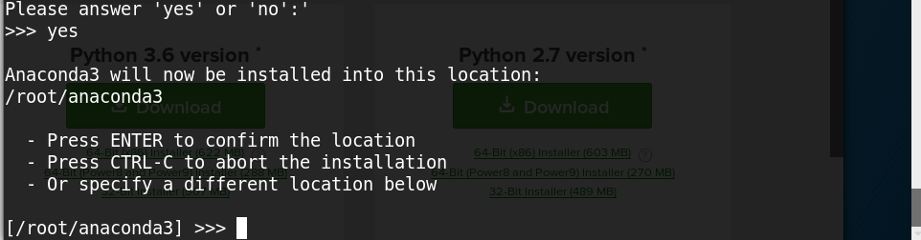

Press Enter

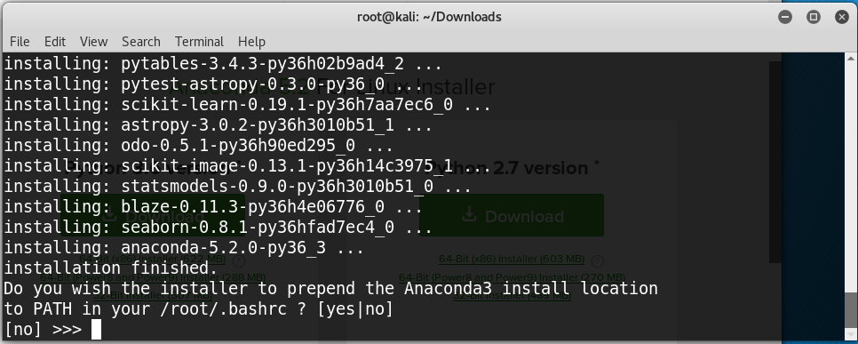

Type Yes

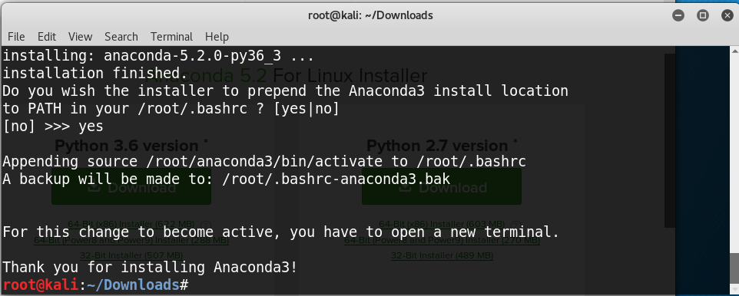

**Open a Terminal window and type:**

root@kali:~# conda --version

conda 4.5.4

**Update conda to the current version. Type the following:**

root@kali:~# conda update conda

**If a newer version of conda is available, type y to update:**

Proceed ([y]/n)? y

**To see a list of all your environments, type:**

root@kali:~# conda info --envs

# conda environments:

#

base * /root/anaconda3

This means only one conda environment named “base” is installed for the moment.

# Simplest way to Launch Python Tools

## Launch interactive Python shell:

root@kali:~# ipython

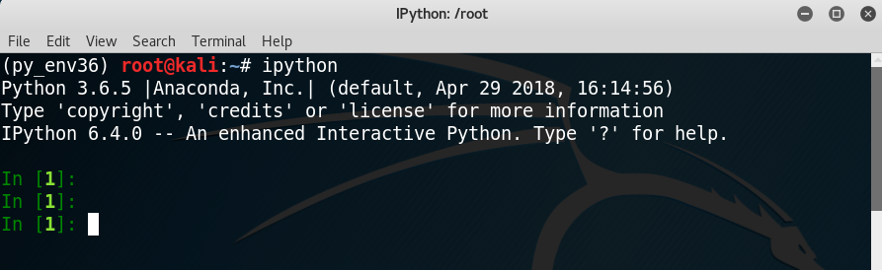

Quit the shell with quit()command

**Launch Jupyter Notebook:**

root@kali:~# jupyter notebook --allow-root

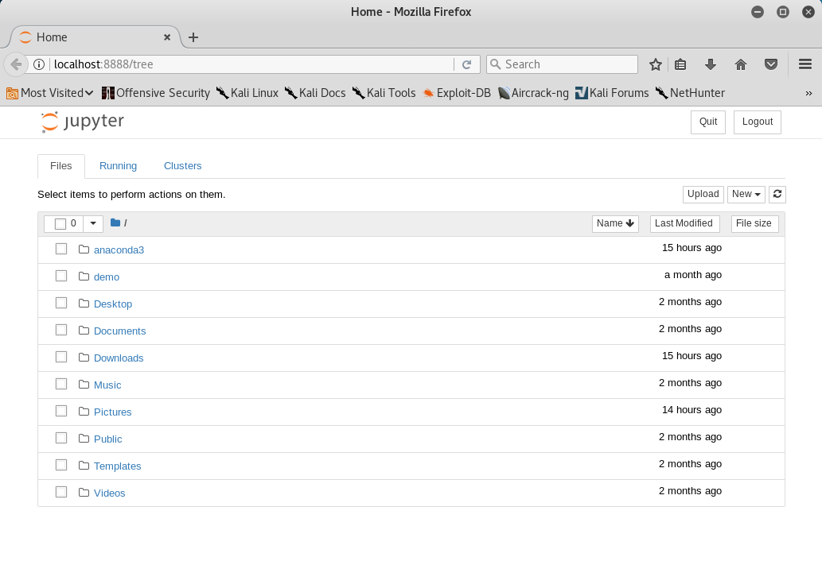

## Installing Atom Editor:

Download it from <https://atom.io/>

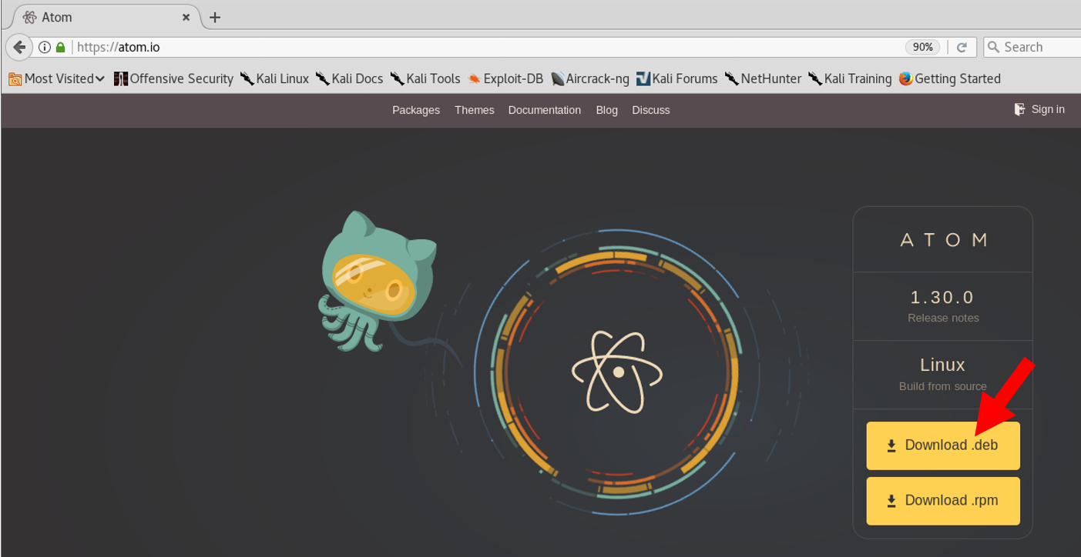

Now type the following commands in bash. We assume that you have downloaded atom-amd64.deb in Downloads directory:

root@kali:~# sudo apt-get update

root@kali:~# sudo dpkg -i Downloads/atom-amd64.deb; sudo apt-get install -f

Now run Atom IDE by typing:

root@kali:~# atom

Now install two needed packages:

Packages -> Settings view -> install packages/themes

